The Web Api can be launched using the following url : <http://localhost:51061/api/v1/Customer> (port number can vary)

When the above URL is launched , all the Customers are returned.



The API can be well tested using Swagger using following url: <http://localhost:51061/swagger/index.html>

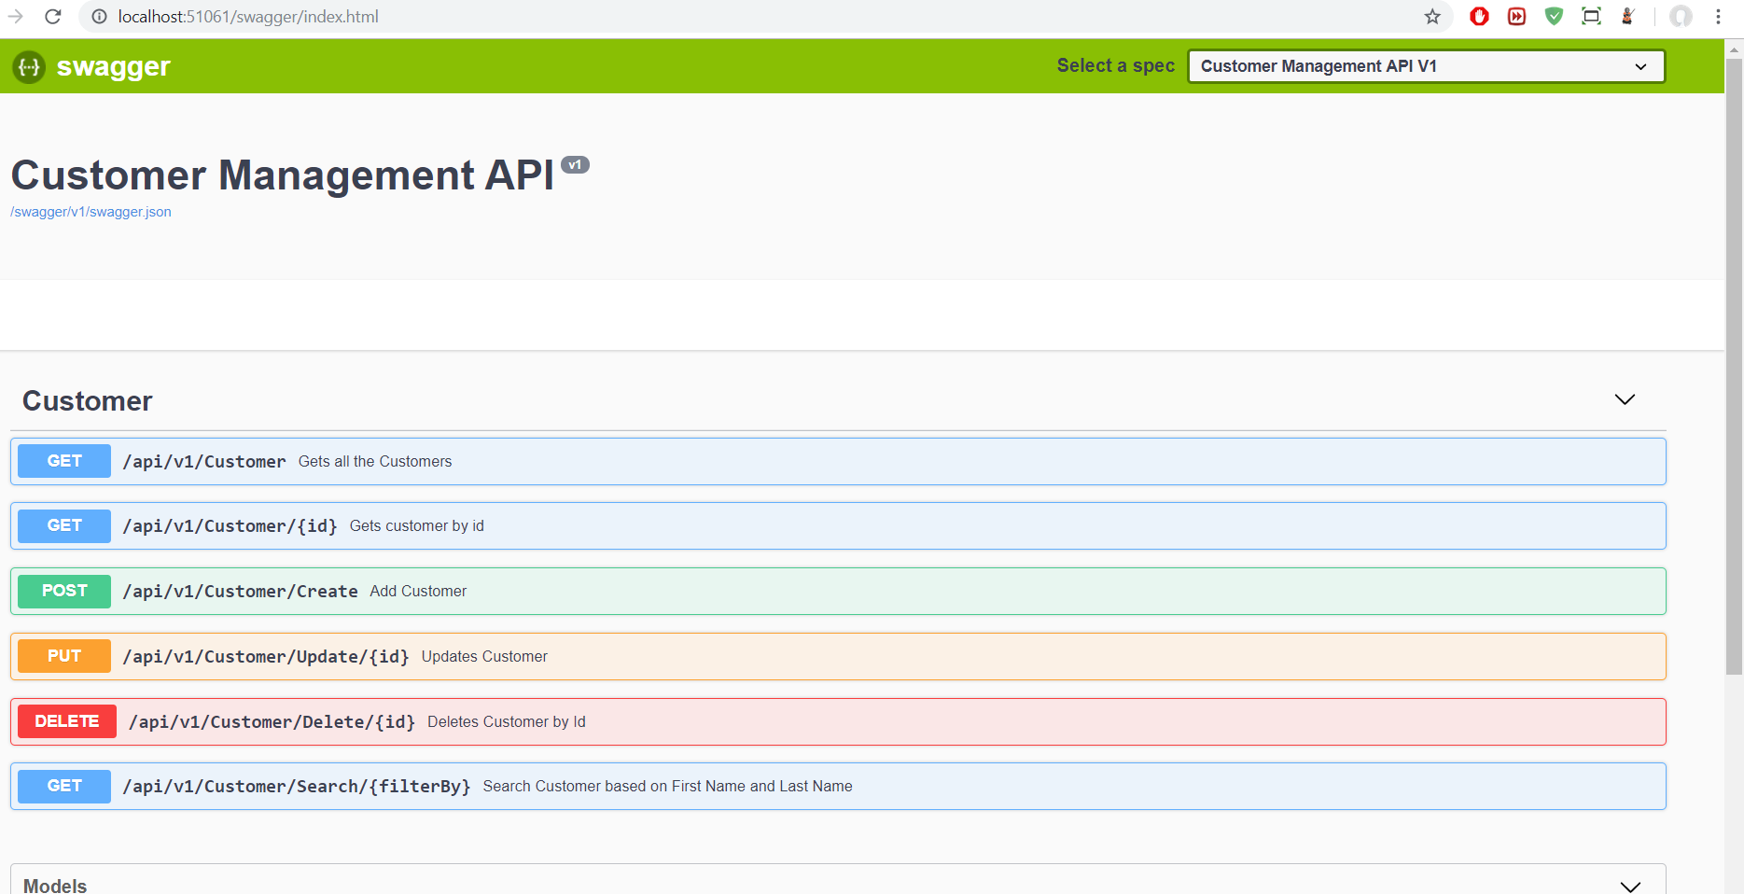

Versioning is defined for the API. The current version is v1 as shown in the swagger index page.

As an example : Create API Call would create object as show below.

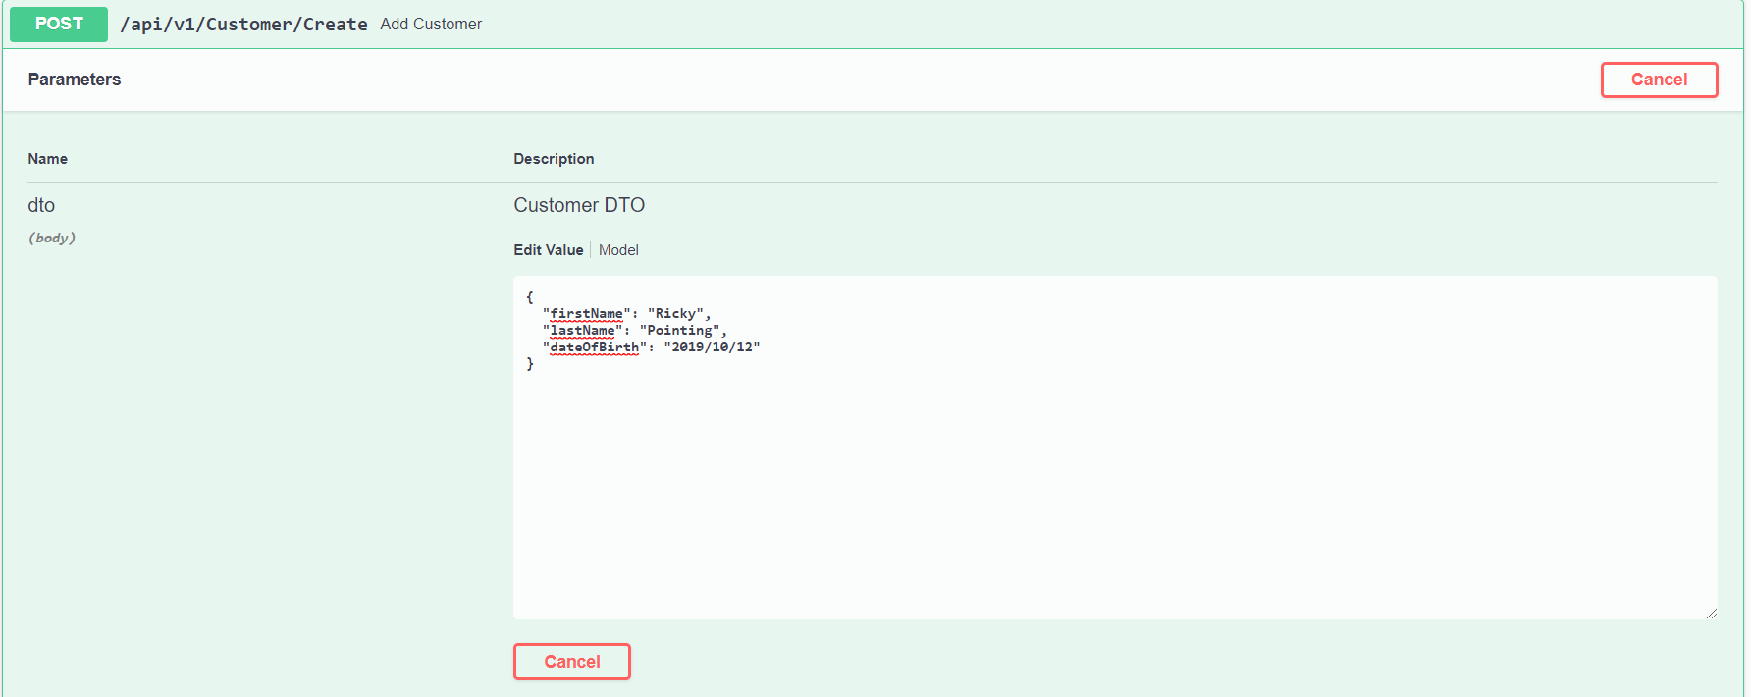

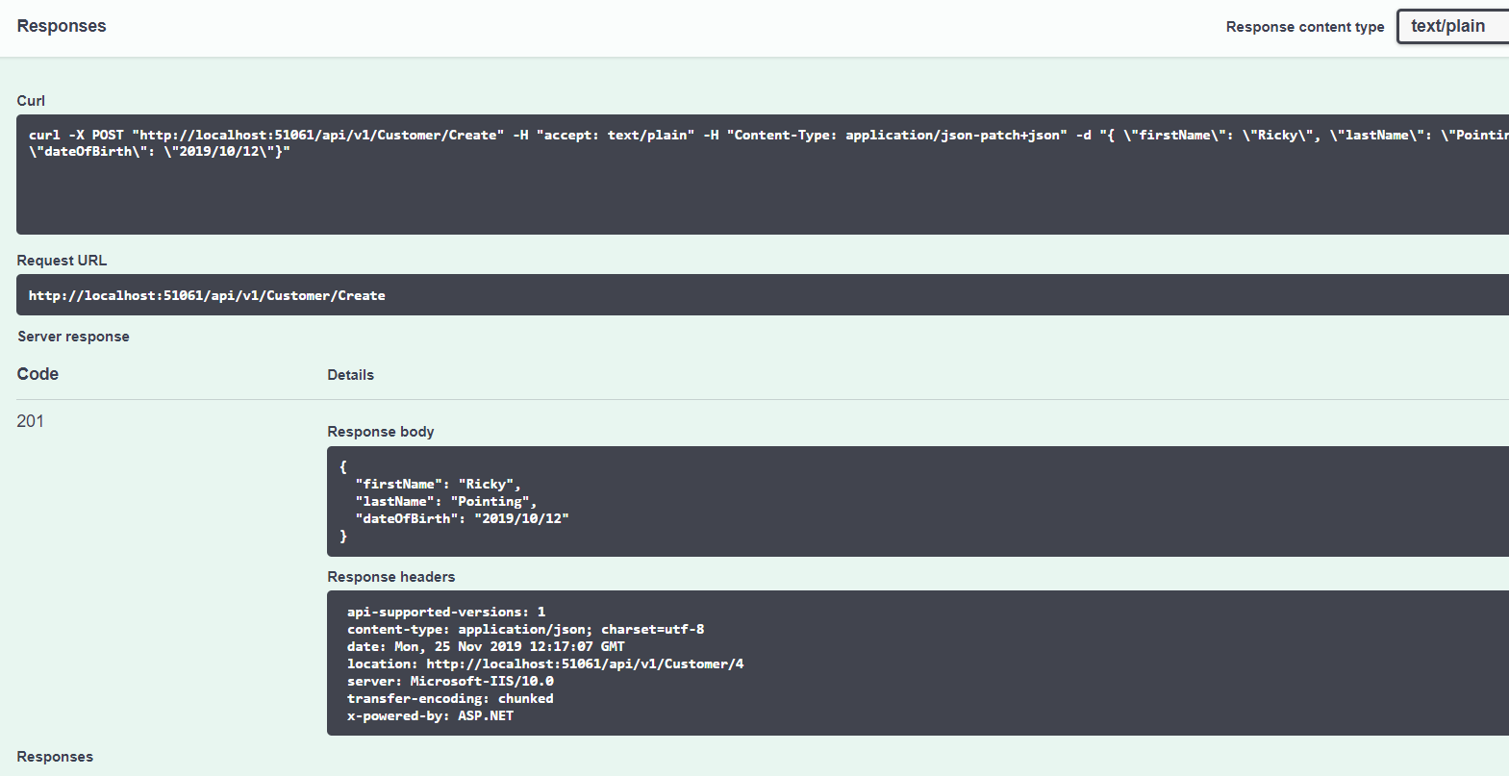

Search by a string as below

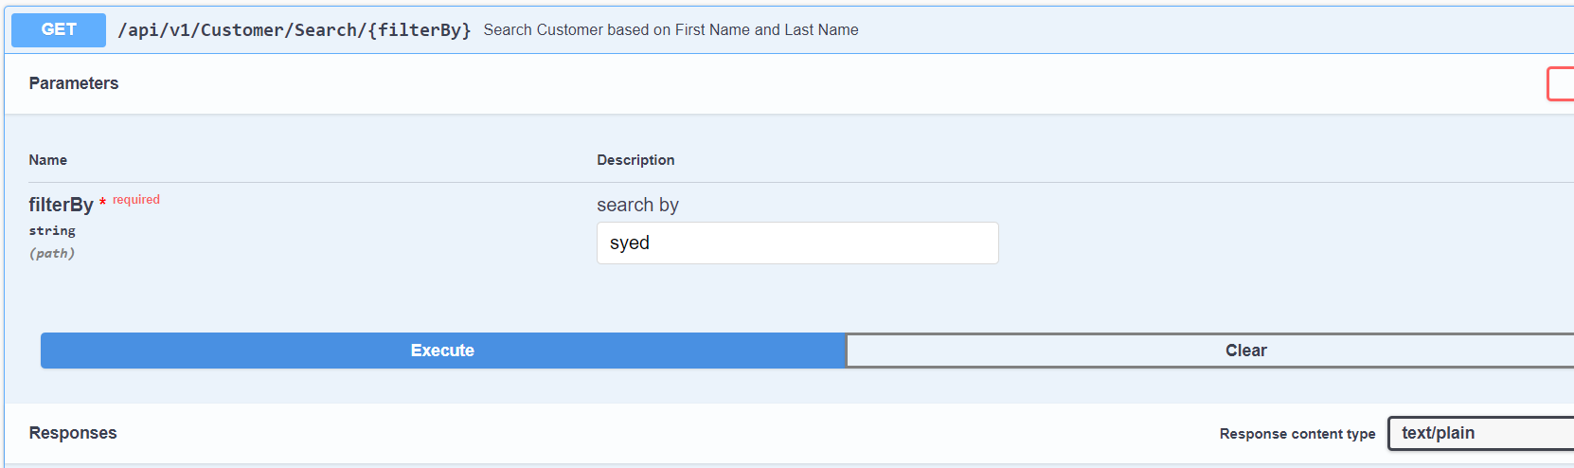

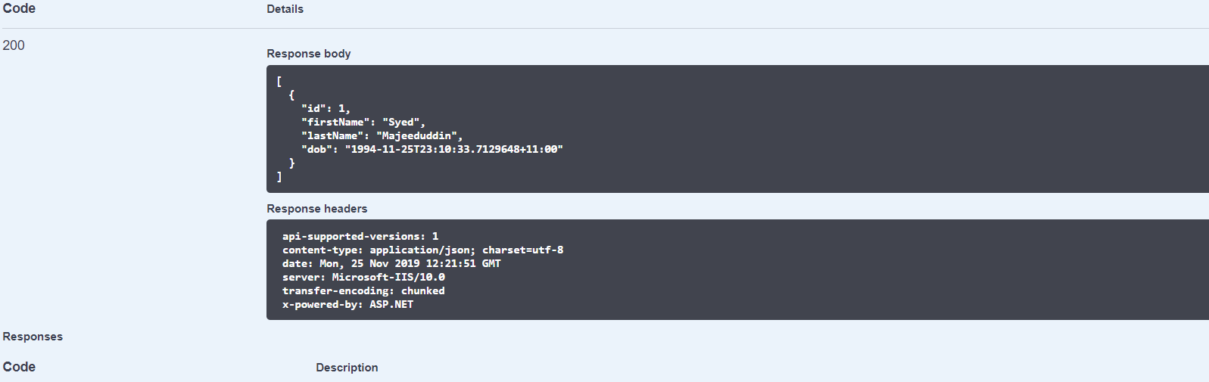

Please note that the Business layer is using EF Core In memory database. So there is no need to have a physical database to run this API.

The Unit Test cases are using EF Core SQL Lite in memory connection for the testing. Please find below the outcome of the test cases.

